**The Manchester Sushi Finder**

Initial Report

Name: Hani Al Abbas

ID: 9057445

Supervisor: Sean Bechhofer

**Abstract**

This document gives an initial idea about The Manchester Sushi Finder Project. The Manchester Sushi Finder is an interface that allows user to interact with an ontology, and construct queries over that ontology and get results instantly. It will be built from scratch based on The Manchester Pizza Finder’s functionalities[1]. The Manchester Pizza Finder main functionality is to communicate with fixed pizza ontology and query for pizza type. The purpose is to make this application more configurable and flexible than Pizza Finder by including the configurations in the OWL ontology as annotations. Also, to aid students to see their ontologies and query on against that them during the development phase, and to explore more aspects of Web Ontology Language (OWL) like using reasoning and querying to drive the application.

Table of Contents

1. INTRODUCTION: 2

2. MOTIVATION: 2

3. AIMS AND OBJECTIVES: 2

Aims: 2

Objectives: 3

4. SCOPE: 3

Within Scope: 3

May fall in the scope: 3

5. PLAN: 4

# INTRODUCTION:

There is an application that provides similar functionalities to what is required in this project. This application is The Manchester Pizza Finder that provide the same functionalities, but with some limitations. A major limitation is that the configuration is fixed and hardcoded. It provides interface between one fixed pizza ontology and one pizza application in one to one relationship. The Manchester Sushi Finder will extend on that project and implement some functionalities that make it more flexible and configurable.

In this project, an application will be built using java. This application will serve as an interface that allows users to interact with an ontology and construct queries over that ontology using OWL API.

This OWL ontology, that the interface interacts with, describes the sushi domain. Users query for sushi types and sushi platters based on ingredients, where is sushi is a piece of any type of sushi, and sushi platter is a dish that contains one or more types of sushi pieces. In the light of this, the interface will be configurable and flexible to allow the selection of sushi platters based on criteria taken from OWL ontology rather that storing it in configuration file.

In this report, the drive behind this project shall be discussed. That is followed by the aims and objectives. Then, defining the scope of the project and the scope of items and functionalities. At the end, it will be concluded with detailed plan.

# MOTIVATION:

The motivation behind this project is to build java application to serve as end front for the sushi ontology. The Manchester pizza finder already do that, so why new java application? The Manchester sushi finder would be more flexible and configurable. The user interface (UI) would be configurable based on what end user preferences. Querying would not be hardcoded anymore link the pizza finder, it would be dynamic by specifying it in ontology annotations. Also, the new sushi finder should work with different ontologies in a condition that must have some standard annotations.

Ontology Engineering and Semantic of the Web course unit gave the foundations and practice required to develop Sushi ontology using OWL. In addition, it introduced java OWLAPI which allows for an ontology to communicate with, and used by applications. The Sushi Ontology was developed using a set of patterns and techniques during the course unit. The Manchester Sushi Finder will make querying for certain sushi or sushi platter more dynamic and easy. Any change that the user makes will impact the result and will be seen.

# AIMS AND OBJECTIVES:

## Aims:

* A set of user stories and acceptance tests for the sushi finder (satisfied by the application).
* An application for sushi selection, which allows the user to select sushi or sushi platter based on certain criteria.
* An evaluation of the project.

## Objectives:

A set of user stories and acceptance tests for the project will be conducted and delivered. As a result, project functionalities will be captured. The user stories focus on gathering the user requirements and putting some acceptance criteria.

The user interface (UI) of the Manchester Sushi Finder application will be built using Java programming language using Swing components like Menus and Trees, etc. The Web Ontology Language (OWL) Application Programming Interface (API), which is Java API, will be used to create the channel between ontology and the application. OWL API can manipulate and serialize OWL Ontologies. Last part of this System is the OWL Ontology which any ontology that contain some specific annotations. Application will be able to query for certain type for sushi or sushi dish.

Evaluation can be conducted via different forms. A prototype will be evaluated by engaging the stakeholders like the supervisor, colleagues, and the personal opinion of the developer. The most important opinion is for the people who will use it. User stories will help to evaluate the product too. The benefits of this project will play a role in the evaluation.

# SCOPE:

In this section, functionalities within scope are defined, and some functionalities that may fall in the scope depending on the time availability.

## Within Scope:

* The user interface will be built using java.
* User interface will be configurable for generic use.
  + Labels are configurable.
* Flexible query building.
  + Ontology driven interface via using annotations.
* Preferences of the user will be saved as configuration for reusability.
* The sushi finder will be a desktop application.
* The sushi finder should work for any ontology with standard annotations defined in them (Configuration will be stored in the ontology).
* User can load ontologies one at a time.
* User can decides which thing to query about (Sushi-Sushi dishes).
* User can query for specific sushi or sushi dish type based on wanted or unwanted ingredients.

## May fall in the scope:

* The sushi finder could be a web application for more accessibility.

# PLAN:

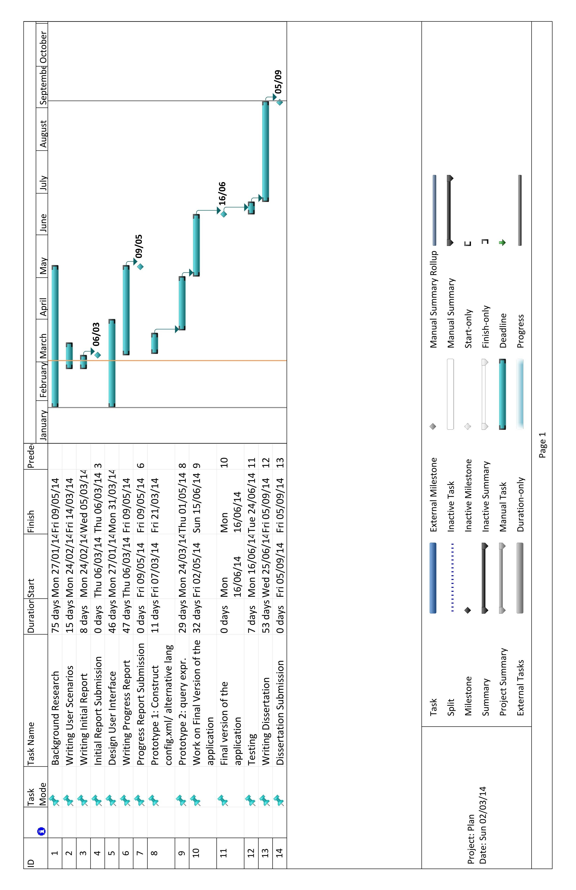

# REFERENCES:

1. ­Matthew Horridge, *The Manchester Pizza Finder* [Desktop Application]. Available at <https://github.com/owlcs/pizzafinder> Accessed (5 March 2014)